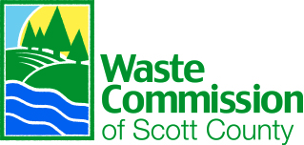

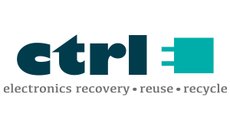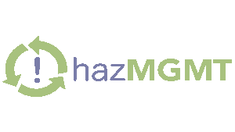

- Roll Call

- Approval of Minutes – August 6, 2026 (enclosure)

- Approval of Treasurer’s Report (enclosure)

- Approval of Invoices (enclosure)

- Presentation of Monthly Operations & Facility Reports (enclosure)

- Consideration of Vehicle Policy (enclosure)

- Consideration of Excavator Recommendation (enclosure)

- Consideration of Balers Recommendation (enclosure)

- Strategic Plan Presentation and Commission feedback

- Other Business

- Public Comment

- Adjournment

October 1, 2026 | 5:00 p.m.
Scott Area Recycling Center | 5640 Carey Ave. Davenport, IA
Zoom Meeting Info: https://us02web.zoom.us/j/83602811422?pwd=jaWijXXuNIaBwvDwCAKMc7csrv91qJ.1
Meeting ID: 836 0281 1422
Passcode: 651966

2026 MEETING SCHEDULE
December 10, 2026
MISSION
To provide sustainable recycling and waste management solutions that positively impact
Scott County.
VISION
We strive to be the industry and community leader in waste management, recycling, and environmental stewardship.
WCSC REPRESENTATIVES
Bryce Stalcup, Executive Director
Brian Seals, Deputy Director
Bobbi Draheim, Finance & Admin Services Mgr.
Megan Fox, Communications & HR Manager
Michael Keppy, Recycling Facility Manager
Nolan Moore, EHS Manager
COMMISSIONERS
Ken Beck, Scott County (Chair)
Anthony Heddlesten, Riverdale (Vice-Chair)
Sally Rodriguez, Buffalo (Secretary-Treasurer)
Robert Gallagher, Bettendorf
Jason Gordon, Davenport
Jade Burkholder, Davenport
COMMISSION MEETING AGENDA

